3GPP TSG-RAN WG4 Meeting #118bis R4-2606186
Dalian, China, April 18th^{th} – 22nd, 2026
Title: Views on feasibility aspects for ISAC
Source: Qualcomm Incorporated
Agenda item: 8.10.3
Document for: Approval

1 Introduction
In [1], a new study item on Study on 6G Radio was approved with the following objectives related to sensing:

Sensing – Studies to be based on use cases and associated requirements, as defined in [TR38.914]
- PHY functions and procedures for sensing technology (e.g., waveform. reference signals, measurement feedback, etc…) [RAN1, RAN4]
- Evaluate sensing performance and if necessary, extend channel modelling, for the selected use cases [RAN1]
- Aspects of integration with communication services [RAN1]
- higher layer procedures and protocol aspects [RAN2]
- RAN4 aspects of sensing including RF, coexistence, and testability in coordination with other WGs [RAN4]
Note: RAN1 identify detailed requirements, if triggered by TSG RAN

Additionally, in RAN4#118bis, a WF was agreed regarding feasibility in RAN4 [2], with the following agreements:
Issue 2-2: Use case and Issue 2-3: Sensing mode
Agreement for the feasibility study for 6G sensing:
- UAV (passive object), TRP monostatic
  - FFS on Multiple TRP monostatic.
- Vehicle (passive object), TRP-UE bistatic
- [TBD] (passive object), UE-TRP bistatic
- UAV (passive object), TRP-TRP bistatic
- In addition to above cases, other sensing modes/scenarios as agreed by RANP and RAN1 could be also studied.

Issue 3-1: General assumption for the feasibility study
Agreement for the prioritized bands to be investigated for ISAC
- FR1 TDD bands +FR2-1 TDD bands;
- Encourage inputs from the operators for the bands;
Agreement:
- RAN4 to use the same 6GR BS and UE assumptions for 6G sensing study as starting point;

Issue 3-2: Feasibility study for TRP/UE mono-static
Agreement:
  - For the feasibility study of mono-static (TRP, UE), propose to consider the following factors:
    - Whether to consider the Tx/Rx separate panels for TRP;
    - Whether to consider the Tx/Rx separate antennas for UE;
    - FFS on the switching time for Tx/Rx switching;
    - FFS on Self interference
    - Quality of received reflected signal
    - Receiver linearity and blocking etc
    - Others are not precluded.
  - The operation mode/sensing waveform depends on the design from other WGs.

Issue 3-3: Feasibility study for TRP-UE and/or UE-TRP bi-static
Agreement:
  - For the feasibility study of TRP-UE and/or UE-TRP bi-static, propose to consider the following factors:
    - FFS for Sensing node’s receiver dynamic range
    - Quality of received reflected signal
    - Synchronization between TRP and UE
    - Others are not precluded.

In this contribution, we share our views on the feasibility aspects with focus on monostatic sensing.

2.1 General feasibility direction
In monostatic sensing, the same node (BS or UE) acts as both transmitter and receiver. One of the design choices is whether sensing signals are transmitted and received simultaneously (i.e., full-duplex) or in time-multiplexed bursts (i.e., TDM/pulse) as shown in Figure 1. Such design choice is tightly related to waveform discussion in RAN1. However, to have some starting point within RAN4, we will consider the trade-offs between the two approaches below. It is expected that till RAN1 decides on the waveform and system design, RAN4 would consider both options in its feasibility analysis.
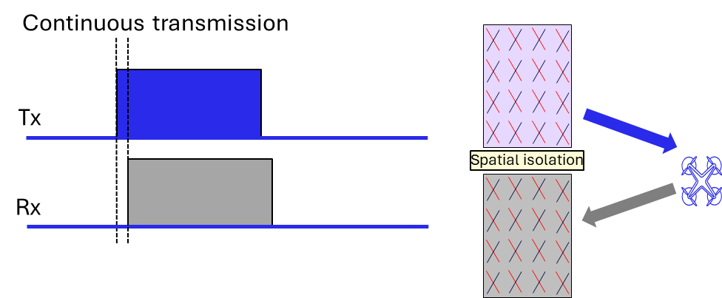 | 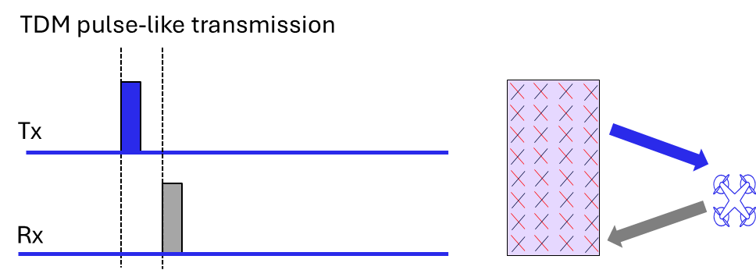
Figure 1 Different sensing transmission modes
Proposal 1: RAN4 to consider both FD-based and TDM-based sensing options for monostatic sensing feasibility analysis.

UE Monostatic sensing via full duplex operation

General
Full-Duplex (FD) Sensing considers a simultaneous transmit-and-receive approach, which eliminates the silent gaps, enabling continuous sensing. The sensing node (BS or UE) can emit a waveform and listen for its reflections/ echoes at the same time, akin to a true radar operation. This maximizes the coherent observation time and refresh rate, which are important for reliable detection and fine doppler/velocity measurements of moving objects. However, FD operation introduces a major challenge which is self-interference. The transmitter’s signal, orders-of-magnitude stronger than any echo, leaks into the co-located receiver. Self-interference cancellation (SIC) at multiple levels (antenna domain, analog/RF, and digital/baseband domain) is needed. RAN4 has experience in this domain within the work of Subband Full Duplex (SBFD) at the BS side in Rel18, Rel19, and Rel20. On the other hand, FD operation at the UE side to enable monostatic sensing needs additional study within RAN4. The sensing capabilities for UE monostatic sensing relies on the achievable SIC capabilities which in turn depend on the UE form factor. Given that RAN4 is in an early stage of the 6G SI, it is our view that UE monostatic sensing should be further analyzed to understand main challenges and corresponding key enablers.
Observation 1: RAN4 has experience on FD-like operation at the BS side given the extensive work on SBFD in NR, while for UE, more analysis might be needed for UE monostatic sensing with FD-like operation.
In our view, RAN4 should conduct a comprehensive feasibility study of FD-based UE monostatic sensing. Our envisioned workplan spans three key steps: First, identify the primary bottlenecks and challenges currently facing UE monostatic sensing, such as SIC capabilities and impacts on sensing performance. Second, propose potential solutions and enhancements to address these challenges, including improvements in SIC mechanisms. Third, evaluate the effectiveness of these solutions using example scenarios, for instance, short-range detection at distances of 5 to 10 meters, with target UE power classes, to calculate the expected echo power and determine the required operating SINR for reliable sensing performance. This approach will help assess whether the achieved cancellation is sufficient for practical sensing applications and guide further development of UE architectures.
Proposal 2: RAN4 to consider UE monostatic sensing in the 6G study item to identify main challenges, performance impacts, and potential RF assumption enhancements from RAN4 perspective.
Proposal 3: RAN4 to assess the UE monostatic feasibility considering AGV/Human detection with specific UE power class assumption and SINR operation point for reliable sensing.

Antenna domain self-interference cancellation
Conceptually, SIC can be realized over multiple stages, namely, passive, analog and digital stages [4]. RAN4 is expected to quantify potential cancellation capabilities at each stage. Passive cancellation, also known as antenna isolation, refers to the case where the self-interference signal is suppressed at the antenna/ propagation domain. This could be realized by employing physically isolated separate antennas for Tx and Rx operation or a shared antenna for both Tx/Rx. For the latter, additional spatial isolation is realized via employing components to provide needed spatial isolation between Tx and Rx signals (e.g., circulator). Within RAN4, General isolation for handheld form factor is around 15-20 dB, while for CPE and vehicular-like devices with spatially far-away antennas, higher than 20 dB of antenna isolation could be considered. For same Tx/Rx architecture and with presence of circulator, exact antenna isolation depends on the device size, cost, operating bandwidth and other factors, but generally larger than 20 dB of antenna isolation could be achieved.
Figure 1 Example of FD architecture with different SIC stages
Observation 2: To realize FD-based UE monostatic sensing, sufficient self-interference cancellation needs to be addressed via multiple cancellation stages (i.e., antenna, analog, and digital domains). RAN4 is expected to quantify potential cancellation capabilities at each stage.
Proposal 4: As a starting point, RAN4 to consider typical RAN4 antenna isolation values for handheld (e.g., 15-20 dB) and CPE/ vehicular (e.g., larger than 20 dB) assuming separate Tx/Rx antennas or shared antennas for Tx/Rx with additional antenna isolation e.g., circulator.

Analog self-interference cancellation
For limited antenna isolation capabilities or high Tx power, additional SIC in the analog domain might be needed in order not to overload the Rx front end and cause the ADC saturation. Since the ADC has a finite dynamic range, if the SI power entering the ADC is too high, the ADC clips (saturates), making it impossible to detect the echo signal in FD-based monostatic operation. A potential solution that has been long investigated is the consideration of analog self-interference cancellation [5], where the SI will be reduced sufficiently so that the SI as well as the weak echo signal fit within the ADC’s linear dynamic range.
Observation 3: For FD-based monostatic sensing, antenna isolation alone might not be enough to prevent the saturation of the UE Rx front-end, thus, necessitating further consideration of analog SIC solutions.
Conceptually, active analog cancellation generates a cancellation signal derived from the known TX waveform, adjusts its amplitude/phase (and/or delay/frequency response), and injects it into the RX path to destructively combine with SI in the analog/RF domain. Example architectures for the analog SIC entail as an example feedforward RF canceller, Multi‑tap analog canceller (several delayed taps to model multipath SI channel), Vector modulator / IQ modulator-based canceller (controls amplitude and phase), and balance network (tunes an RF network so that the leakage is nulled at a hybrid/combiner node). Different solutions have different advantages and costs. It is expected that RAN4 would further discuss potential solutions for analog SIC as well as their corresponding SIC capabilities for FD-based UE monostatic sensing. Naturally, several limitations for the analog SIC might exist, for example, for wideband operation, multi-tab frequency selective cancellation might be needed, which requires additional complexity on the UE side. Additional residual self-interference might still be there due to non-linear SI residuals, which require additional cancellation in the digital/baseband domain.
Proposal 5: RAN4 to investigate analog self-interference cancellation solutions, their corresponding SIC capabilities, and imposed cost/complexity for FD-based UE monostatic sensing

Digital self-interference cancellation
As mentioned earlier, the goal of the full SIC chain is to suppress residual SI in FD-based UE monostatic sensing down, so that the weak target echo is detectable. Based on the sensing scenario, UE power class (i.e., maximum output power), and sensing operation, the echo received power at short distances (e.g., 5m or 10m) could be in the range of -65 dBm to -75dBm, while for a 100 MHz bandwidth with 10 dB UE Noise figure, the noise floor is at ~-84 dBm. Thus, to reach sufficient residual SIC, additional mitigation in the digital domain is needed. It is expected that RAN4 would investigate realistic digital SIC solutions for FD-based UE monostatic sensing as well as their corresponding challenges.
Proposal 6: RAN4 to consider digital self-interference cancellation solutions as well as their corresponding SIC capabilities and additional cost for FD-based UE monostatic sensing.

UE Monostatic sensing via TDM-based operation
TDM-based sensing partitions the sensing time slot into separate Tx Rx intervals, typically following a pulse-like operation. During a sensing interval (or radar pulse), the UE transmits a sensing waveform and then listens for its echoes in a subsequent quiet period. The benefits are absence of any self-interference and potentially higher transmit power. However, such operation design has its limitations as alternating between Tx and Rx creates “blind” intervals when the sensing node is not in listening, leading to a degradation in the ability to detect fast-moving targets, which might lead to missed detections during Tx periods.
Observation 2: TDM-based monostatic sensing avoids self-interference and enables potential higher transmit power compared to FD-based monostatic sensing but introduces blind intervals that may impact detection of fast-moving targets.
Assuming we consider a distance of 75 meters as blind range/ exclusion distance, the required Tx to Rx switching to meet this would be around 0.5 usec, which is much lower than general Tx/Rx switching requirements we had for communication in NR. In order for RAN4 to better quantify the needed switching time for TDM-based operation, further discussion is needed on the sensing scenarios and accompanying requirements.
Proposal 7: RAN4 to discuss sensing scenario and accompanying requirements on blind range detection needed for TDM-based monostatic sensing to better quantify the needed Tx/Rx switching requirements.

Coherence and phase continuity in a CPI
Coherency and phase continuity across symbols within a CPI cannot be assumed by default. They are only valid if the UE/BS RF state remains unchanged over the CPI, i.e., no discrete RF, scheduling, or control events occur that can introduce a phase reset, phase step, or transient. In particular, CPI‑level coherence requires that the same oscillator and RF chain configuration is maintained (e.g., no RF chain re-selection, no antenna/panel switching, and no change in duplexing/transmission direction) such that the residual CFO, phase noise, and drift over the CPI stay sufficiently small for the accumulated phase rotation to be either negligible or predictable/compensable by the receiver’s estimation/tracking. Any event that changes the UE/BS RF state or timing/control state (e.g., power re-scaling, BWP change, frequency hopping, DRX/inactivity transitions, measurement gaps, or retuning) may introduce phase discontinuity and should be treated as breaking coherent integration. Additionally, Symbol-level mixing (e.g., SBFD vs non‑SBFD slot/symbol configuration) can introduce RF transients (switching time, ON/OFF masks, etc.) or effective channel aging that invalidates CPI‑level phase continuity assumptions. Therefore, within RAN4 feasibility framework it is important to identify main challenges to maintain coherency and phase continuity within the agreed CPI window. In terms of exact CPI values, RAN4 could assume set of CPI numbers for different use cases, but it is our view that RAN1 would be responsible for evaluating the CPI for the different use cases under investigation.
Proposal 8: RAN4 to identify main challenges to maintain coherency and phase continuity within the agreed CPI window.

6 AAS assumptions for BS-based sensing
Antenna configurations and beamforming characteristics in ISAC deployments may differ from standard communication setups. For example, sensing use cases (especially at higher frequencies like ~7 GHz or for UAV detection) might demand finer angular resolution, which depends on the antenna array size and resulting radiation pattern. Thus, RAN4 should evaluate if existing AAS parameters (e.g. n104 or AAS parameters given in TR 38.922 for 7-8 GHz) will be the baseline for ISAC use cases and scenarios. RAN4 should discuss whether the defined azimuth/elevation beamwidths and AAS assumptions can meet the angular resolution requirements of envisioned sensing use cases (e.g., UAV detection and/or tracking). If not, adjustments or new AAS parameters may be needed to reflect practical ISAC antenna designs (e.g., larger arrays or AAS configurations for sensing).
Proposal 9: RAN4 to confirm if AAS assumptions given in TR 38.922 will be the baseline for the ISAC studies within RAN4 6G SI.

3 Conclusion
In this contribution, we provided our views on the feasibility study of ISAC within RAN4 with the following observations:
Proposal 1: RAN4 to consider both FD-based and TDM-based sensing options for monostatic sensing feasibility analysis.
Observation 1: RAN4 has experience on FD-like operation at the BS side given the extensive work on SBFD in NR, while for UE, more analysis might be needed for UE monostatic sensing with FD-like operation.
Proposal 2: RAN4 to consider UE monostatic sensing in the 6G study item to identify main challenges, performance impacts, and potential RF assumption enhancements from RAN4 perspective.
Proposal 3: RAN4 to assess the UE monostatic feasibility considering AGV/Human detection with specific UE power class assumption and SINR operation point for reliable sensing.
Observation 2: To realize FD-based UE monostatic sensing, sufficient self-interference cancellation needs to be addressed via multiple cancellation stages (i.e., antenna, analog, and digital domains). RAN4 is expected to quantify potential cancellation capabilities at each stage.
Proposal 4: As a starting point, RAN4 to consider typical RAN4 antenna isolation values for handheld (e.g., 15-20 dB) and CPE/ vehicular (e.g., larger than 20 dB) assuming separate Tx/Rx antennas or shared antennas for Tx/Rx with additional antenna isolation e.g., circulator.
Observation 3: For FD-based monostatic sensing, antenna isolation alone might not be enough to prevent the saturation of the UE Rx front-end, thus, necessitating further consideration of analog SIC solutions.
Proposal 5: RAN4 to investigate analog self-interference cancellation solutions, their corresponding SIC capabilities, and imposed cost/complexity for FD-based UE monostatic sensing.
Proposal 6: RAN4 to consider digital self-interference cancellation solutions as well as their corresponding SIC capabilities and additional cost for FD-based UE monostatic sensing.
Observation 2: TDM-based monostatic sensing avoids self-interference and enables potential higher transmit power compared to FD-based monostatic sensing but introduces blind intervals that may impact detection of fast-moving targets.
Proposal 7: RAN4 to discuss sensing scenario and accompanying requirements on blind range detection needed for TDM-based monostatic sensing to better quantify the needed Tx/Rx switching requirements.
Proposal 8: RAN4 to identify main challenges to maintain coherency and phase continuity within the agreed CPI window.
Proposal 9: RAN4 to confirm if AAS assumptions given in TR 38.922 will be the baseline for the ISAC studies within RAN4 6G SI.

4 References

[1] RP-251881, Study on 6G Radio, NTT DOCOMO (Moderator), RAN Meeting #108, Prague, Czech Republic.
[2] R4-2604942 “Way Forward for [118bis][362] 6G_Sensing” Feature Lead (ZTE), RAN4#118bis, St. Julians, Malta.
[3] R4-2604669, “Topic Summary for [118bis][ 362] ISAC ”, ZTE, RAN4#118bis, St. Julians, Malta.
[4] D. Korpi, J. Tamminen, M. Turunen, T. Huusari, Y.-S. Choi, L. Anttila, S. Talwar, and M. Valkama, “Full-duplex mobile device: Pushing the limits,” IEEE Communications Magazine, vol. 54, no. 9, pp. 80–87, Sep. 2016.
[5] J. W. Kwak, M. S. Sim, I. -W. Kang, J. Park, K. -K. Wong and C. -B. Chae, "Analog Self-Interference Cancellation With Practical RF Components for Full-Duplex Radios," in IEEE Transactions on Wireless Communications, vol. 22, no. 7, pp. 4552-4564, July 2023.

